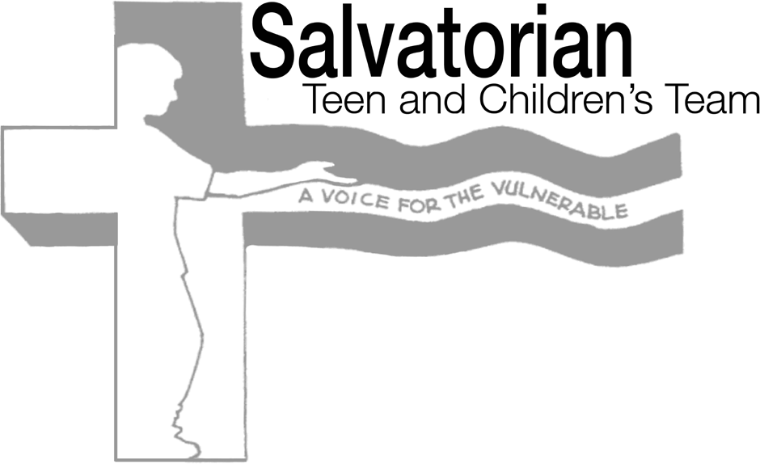

Dear Senator:

There’s enough evidence around that online platforms have had a harmful effect on children and teens: fostering body image issues, creating addictive use, promoting products that are dangerous for young audiences, and fueling bullying and other destructive behaviors. The Kids Online Safety Act of 2023 provides kids and parents with the tools, safeguards, and transparency they need to protect against threats to children’s health and well-being online.

We especially commend two features in the Bill: giving parents new controls to help support their children and spot harmful behaviors, including providing them a dedicated channel to report any harms to kids; and requiring large social media platforms to perform an annual independent audit that assesses the risks to minors.

Although not perfect, the Bill goes a long way to assure safeguards and a measure of transparency so sorely needed. We urge your passage of this important legislation.

Sincerely yours,

